~~~~~~~~Breathing for Music~~~~~~~~

In singing or in playing a wind instrument, AIR makes the music!!

When we breathe in order to sing or play music, we take in and push out more air than we do doing our normal activities.

All day long, when you breathe in, your belly goes out. It does this to make room for all that extra air that’s now in your body. When you exhale, your belly goes in, helping to push the air back out. The only time that we don’t do this is when we become self-conscious about our breathing. Check it out next time you’re sleeping or doing exercise. Inhale Exhale ……… Expand Contract

This is your chest and belly as you fill up. Make sure not to stop after filling the top!
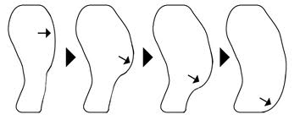
The bigger your exhale, the fuller your next inhale will be.

Since you need to breathe more deeply for music, you will feel a little fuller than normal when you breathe in, and a little uncomfortable when you breathe out. Pretty soon you’ll get used to it, and find that it even feels good to breathe so fully! 