Have you hit a PLATEAU?!

Maybe you could change up your approach! Have you tried out all of these PRACTICE TECHNIQUES?

12 Ways (actually 30+s ways to practice a technical passage)

Tempo Chart 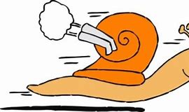 Adagio

Woodshedding Brick-by-Brick 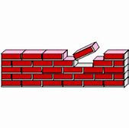

Your-Own-Tempo – vary speed as needed

Blocked Practice vs Interleaved Practice

ROGUES GALLERY

